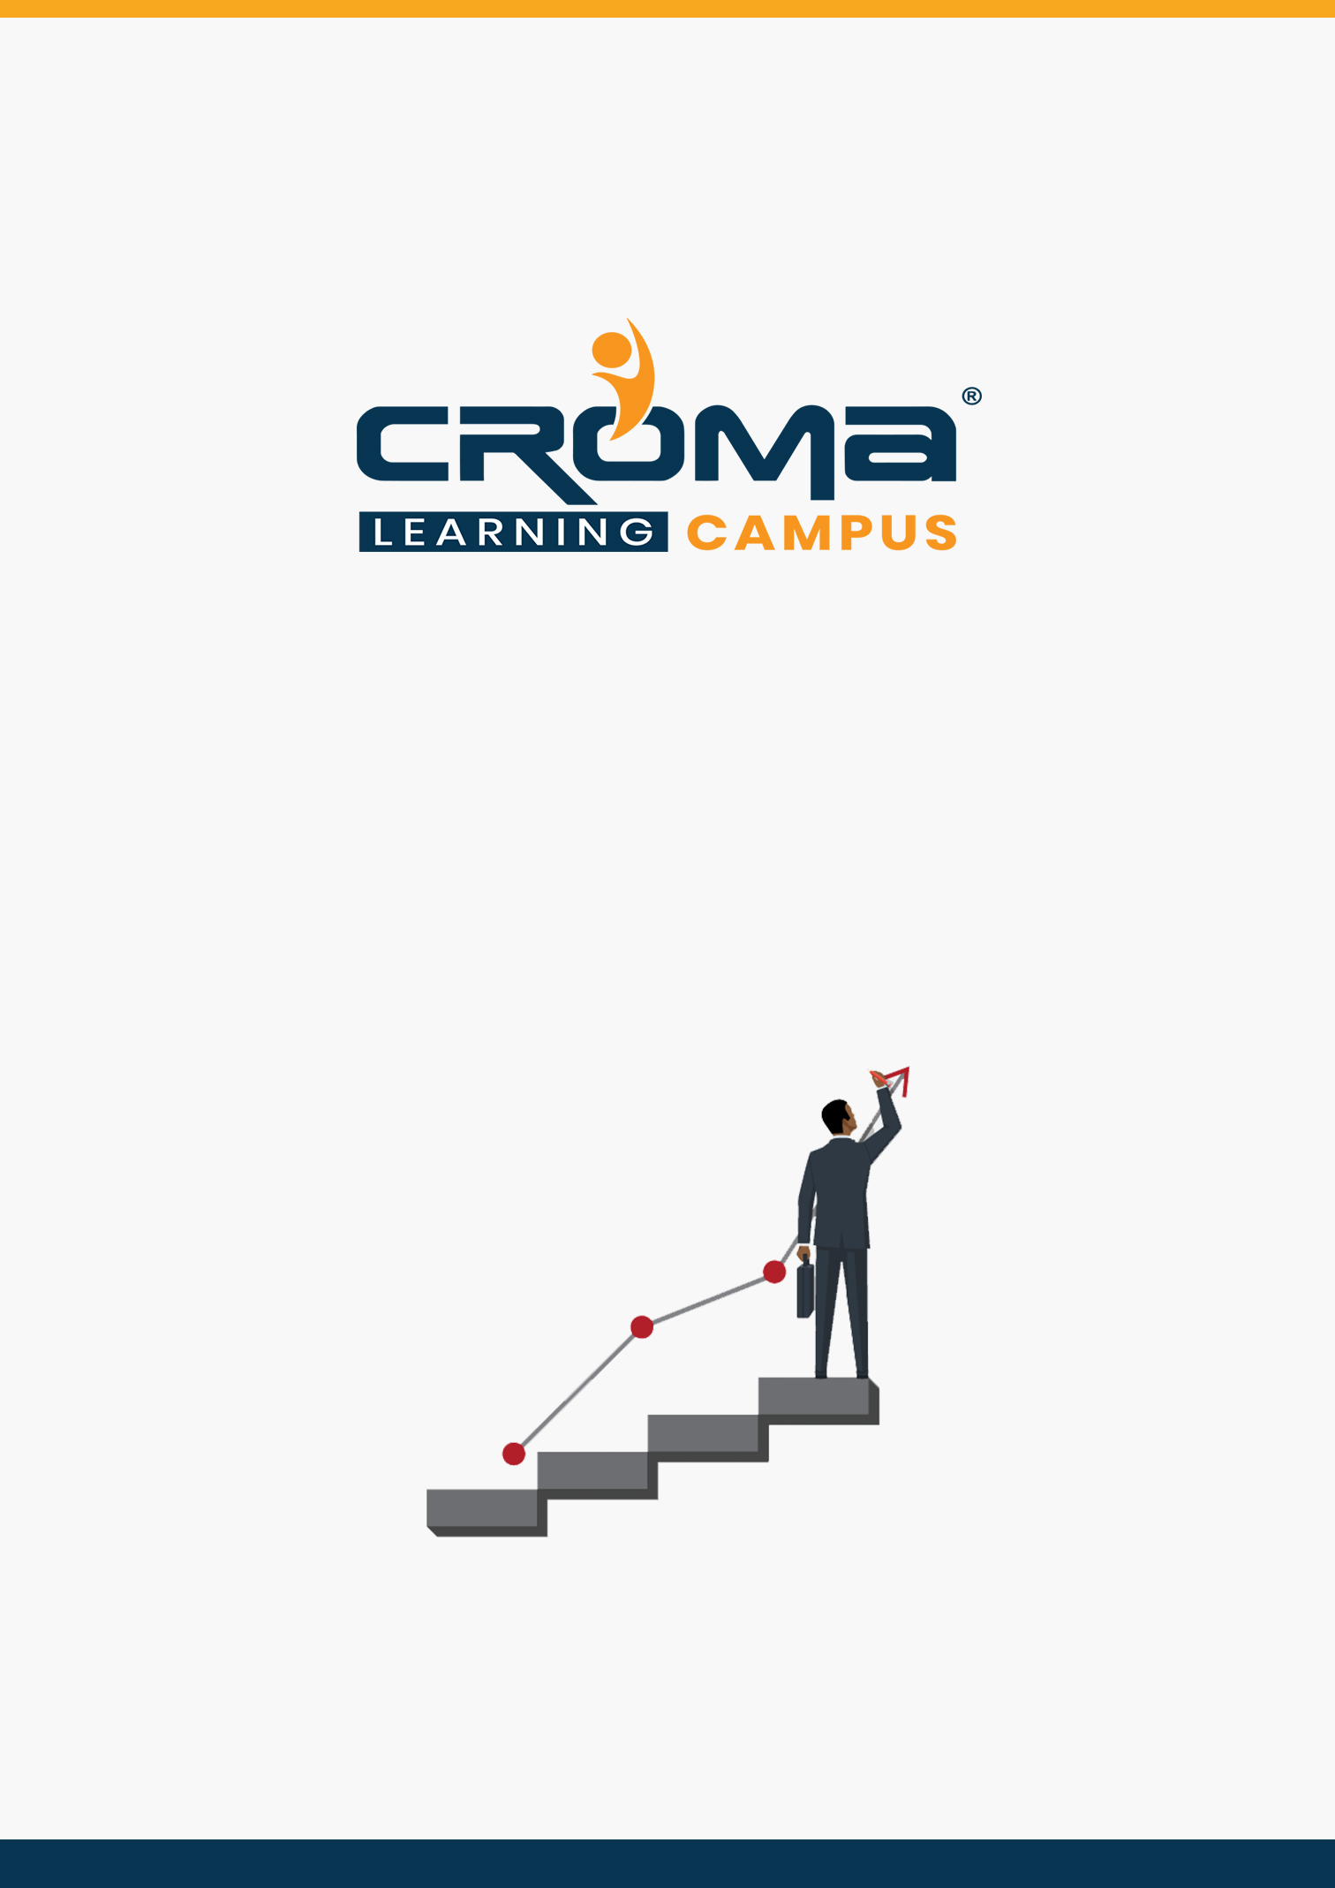

**AZ-303 Microsoft Azure Architect Technologies Training Curriculum**

**STRUCTURE**

**www.cromacampus.com | helpdesk@cromacampus.com | +91-120-4155255**

**AZ-303 Microsoft Azure Architect Technologies Training Curriculum**

*“Learn translating complex business requirements into reliable and scalable cloud solutions with our detailed Curriculum for AZ 303 Certification Training”*

**Course Objectives:**

* Prepare yourself for the certification exam and clear your certification exam in the first attempt
* Add an attractive credential in your resume that is really appreciated by Companies.
* Improve your overall Cloud management skills, azure development skills, solution designing, implementation skills, and explore more job prospects with better salary packages.
* Boost your social media profiles especially LinkedIn by adding this certification and become one of the top persons to be chosen by industries.

**AZ 303 Certification Training Description:**

The job role and responsibilities for an Azure Solution Architect include advising stakeholders and translating business requirements into secure, scalable, and reliable cloud solutions. Also, an Azure Solution Architect partners with cloud administrators, cloud DBAs, and clients to implement solutions.

After joining our Training program at Croma Campus, you will gain subject matter expertise in designing and implementing solutions that run on Microsoft Azure, including aspects like compute, network, storage, and security.

***Here are some strong reasons why should you consider this certification course.***

* Validate your technical skills like storage, networking, compute, security, and other Cloud operations on Microsoft Azure.
* Validate your solution designing and architect skills by successful implementation of cloud solutions at the workplace.
* Top-paying info-tech certification in the world.
* It provides you with global recognition for your knowledge, skills, and experience.
* The organization looks for those who know Oracle Cloud, AWS, Azure, etc.

**Prerequisites for the Certification Exam:**

A candidate for this exam should have advanced experience and knowledge across various aspects of IT operations, including networking, virtualization, identity, security, business continuity, disaster recovery, data management, budgeting, and governance–this role should manage how decisions in each area affect an overall solution.

In addition, this role should be proficient in at least one of these Azure knowledge domains: AZ 103 administration, AZ 203 development, or DevOps.

**Necessary Details about Certification You must Know**

* Certification Name – AZ-303 Microsoft Azure Architect Technologies
* Exam Duration: 150 minutes
* Number of Questions: 40-60
* Passing score: 700 (Out of 1000)
* Exam Cost: USD 165.00
* Validity: 2 years

**Certification Exam Structure:**

* Implement and monitor an Azure infrastructure (50-55%)
* Implement management and security solutions (25-30%)
* Implement solutions for apps (10-15%)
* Implement and manage data platforms (10-15%)

**Course Content:**

**Module 1: Implement and Monitor an Azure Infrastructure**

**Implement Cloud Infrastructure Monitoring**

* monitor security
* monitor performance
  + configure diagnostic settings on resources
  + create a performance baseline for resources
  + monitor for unused resources
  + monitor performance capacity
  + visualize diagnostics data using Azure Monitor
* monitor health and availability
  + monitor networking
  + monitor service health
* monitor cost
  + monitor spends
  + report on spend
* configure advanced logging
  + implement and configure Azure Monitor insights, including App Insights, Networks and Containers
  + configure a Log Analytics workspace
* configure logging for workloads
* initiate automated responses by using Action Groups
* configure and manage advanced alerts
  + collect alerts and metrics across multiple subscriptions
  + view Alerts in Azure Monitor logs
  + NOT: create Log Analytics query

**Implement storage accounts**

* select storage account options based on a use case
* configure Azure Files and blob storage
* configure network access to the storage account
* implement Shared Access Signatures and access policies
* implement Azure AD authentication for storage
* manage access keys
* implement Azure storage replication
* implement Azure storage account failover

**Implement VMs for Windows and Linux**

* configure High Availability
* configure storage for VMs
* select virtual machine size
* implement Azure Dedicated Hosts
* deploy and configure scale sets
* configure Azure Disk Encryption

**Automate deployment and configuration of resources**

* save a deployment as an Azure Resource Manager template
* modify Azure Resource Manager template
* evaluate location of new resources
* configure a virtual disk template
* deploy from a template
* manage a template library
* create and execute an automation runbook

**Implement virtual networking**

* implement VNet to VNet connections
* implement VNet peering

**Implement Azure Active Directory**

* add custom domains
* configure Azure AD Identity Protection
* implement self-service password reset
* implement Conditional Access including MFA
* configure user accounts for MFA
* configure fraud alerts
* configure bypass options
* configure Trusted IPs
* configure verification methods
* implement and manage guest accounts
* manage multiple directories

**Implement and Manage Hybrid Identities**

* install and configure Azure AD Connect
* identity synchronization options
* configure and manage password sync and password writeback
* configure single sign-on
* use Azure AD Connect Health

**Module 2: Implement Management and Security Solutions**

**Manage workloads in Azure**

* migrate workloads using Azure Migrate
  + assess infrastructure
  + select a migration method
  + prepare the on-premises for migration
  + recommend target infrastructure
* implement Azure Backup for VMs
* implement disaster recovery
* implement Azure Update Management

**Implement load balancing and network security**

* implement Azure Load Balancer
* implement an application gateway
* implement a Web Application Firewall
* implement Azure Firewall
* implement the Azure Front Door Service
* implement Azure Traffic Manager
* implement Network Security Groups and Application Security Groups
* implement Bastion

**Implement and manage Azure governance solutions**

* create and manage hierarchical structure that contains management groups, subscriptions and resource groups
* assign RBAC roles
* create a custom RBAC role
* configure access to Azure resources by assigning roles
* configure management access to Azure
* interpret effective permissions
* set up and perform an access review
* implement and configure an Azure Policy
* implement and configure an Azure Blueprint

**Manage security for applications**

* implement and configure Key Vault
* implement and configure Managed Identities
* register and manage applications in Azure AD

**Module 3: Implement Solutions for Apps**

**Implement an application infrastructure**

* create and configure Azure App Service
* create an App Service Web App for Containers
* create and configure an App Service plan
* configure an App Service
* configure networking for an App Service
* create and manage deployment slots
* implement Logic Apps
* implement Azure Functions

**Implement container-based applications**

* create a container image
* configure Azure Kubernetes Service
* publish and automate image deployment to the Azure Container Registry
* publish a solution on an Azure Container Instance
* NOT: Service Fabric

**Module 4: Implement and Manage Data Platforms**

**Implement NoSQL databases**

* configure storage account tables
* select appropriate Cosmos DB APIs
* set up replicas in Cosmos DB

**Implement Azure SQL databases**

* configure Azure SQL database settings
* implement Azure SQL Database managed instances
* configure HA for an Azure SQL database
* publish an Azure SQL database

**Module 5: Placement Guide**

* Tips to clear an Interview
* Common Interview questions and answers
* AZ 303 Interview Questions and Answers
* Resume Building Guide
* Attempt for AZ 303 Global Certification Exam
* Start applying for Jobs